**Chapter 3**

**Derivatives**

**3.1 Defining the Derivative**

**Section Exercises**

**For the following exercises, use Equation_03_01_03 to find the slope of the secant line between the values  and  for each function**

1. 

Answer: 

3. 

Answer:

5. 

Answer:

7. 

Answer:

9. 

Answer:

**For the following functions,**

1. **use Equation_03_01_04 to find the slope of the tangent line  and**
2. **find the equation of the tangent line to  at **

11. 

Answer: a. b. 

13. 

Answer: a.  b. 

15. 

Answer: a.  b. 

17. 

Answer: a.  b. 

19. 

Answer: a. b. 

**For the following functions , find  using Equation_03_01_03.**

21. 

Answer: 

23. 

Answer: 

25. 

Answer:

27. 

Answer: 

29. 

Answer: 

**For the following exercises, given the function**

1. **find the slope of the secant line  for each point  with  value given in the table.**
2. **Use the answers from a. to estimate the value of the slope of the tangent line at **
3. **Use the answer from b. to find the equation of the tangent line to  at point **

31. **[T]**  (Round to  decimal places.)

|  |  |  |  |
| --- | --- | --- | --- |
| *x* | Slope | *x* | Slope |
| 1.1 | (i) | 0.9 | (vii) |
| 1.01 | (ii) | 0.99 | (viii) |
| 1.001 | (iii) | 0.999 | (ix) |
| 1.0001 | (iv) | 0.9999 | (x) |
| 1.00001 | (v) | 0.99999 | (xi) |
| 1.000001 | (vi) | 0.999999 | (xii) |

Answer: a.            b.  c. 

33. **[T]**  (Round to decimal places.)

|  |  |
| --- | --- |
| *x* | Slope |
|  | (i) |
|  | (ii) |
|  | (iii) |
|  | (iv) |
|  | (v) |
|  | (vi) |

Answer: a. (i)  (ii) (iii), (iv) (v) (vi)  b.  c. 

**[T] For the following position functions  an object is moving along a straight line, where  is in seconds and  is in meters. Find**

1. **the simplified expression for the average velocity from to;**
2. **the average velocity between  and  where (i)  (ii)  (iii)  and (iv)  and**
3. **use the answer from a. to estimate the instantaneous velocity at second.**

35. 

Answer: a. ; b. (i)  m/s, (ii)  m/s, (iii)  m/s, (iv)  m/s; c.  m/s

37. 

Answer: a. b. (i)  m/s, (ii)  m/s, (iii)  m/s, (iv)  m/s; c. m/s

39. Use the following graph to evaluate a.  and b. 

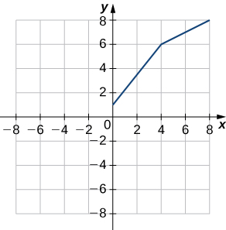

Answer: a. b. 

**For the following exercises, use the limit definition of derivative to show that the derivative does not exist at for each of the given functions.**

41. 

Answer: 

43. 

Answer: 

45. **[T]** The position in feet of a race car along a straight track after  seconds is modeled by the function

1. Find the average velocity of the vehicle over the following time intervals to four decimal places:
   1. [4, 4.1]
   2. [4, 4.01]
   3. [4, 4.001]
   4. [4, 4.0001]
2. Use a. to draw a conclusion about the instantaneous velocity of the vehicle at seconds.

Answer: a. (i)  ft/s, (ii)  ft/s (iii)  ft/s (iv)  ft/s b. At  seconds the race car is traveling at a rate/velocity of  ft/s

47. Two vehicles start out traveling side by side along a straight road. Their position functions, shown in the following graph, are given by  and  where  is measured in feet and  is measured in seconds.

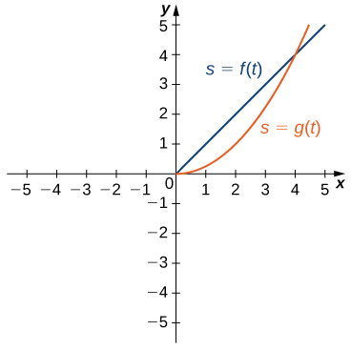

1. Which vehicle has traveled farther at  seconds?
2. What is the approximate velocity of each vehicle at  seconds?
3. Which vehicle is traveling faster at  seconds?
4. What is true about the positions of the vehicles at  seconds?

Answer: a. The vehicle represented by  because it has traveled  feet, whereas  has traveled  foot. b. The velocity of  is constant at  ft/s, while the velocity of  is approximately  ft/s. c. The vehicle represented by  with a velocity of approximately  ft/s. d. Both have traveled  feet in  seconds

49. **[T]** For the function  do the following.

1. Use a graphing calculator to graph *f* in an appropriate viewing window.
2. Use the ZOOM feature on the calculator to approximate the two values of  for which 

Answer: a.

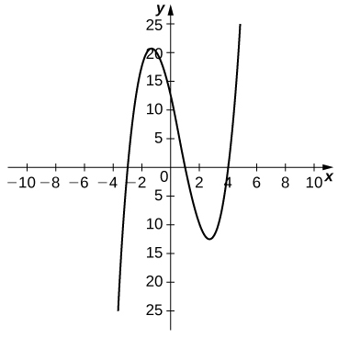

b. 

51. Suppose that  computes the number of gallons of gas used by a vehicle traveling  miles. Suppose the vehicle gets  mpg.

1. Find a mathematical expression for .
2. (b)What is ? Explain the physical meaning.
3. What is  Explain the physical meaning.

Answer: a.  b.  gallons. When the vehicle travels  miles, it has used  gallons of gas. c. The rate of gas consumption in gallons per mile that the vehicle is achieving after having traveled  miles.

53. [**T]** For the function  do the following.

1. Use a graphing calculator to graph  in an appropriate viewing window.
2. Use the  function on a graphing calculator to find  and 

Answer: a.

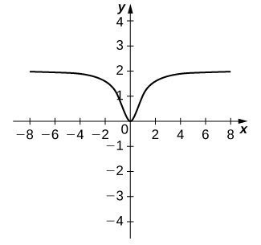

b. 

This file is copyright 2016, Rice University. All Rights Reserved.